By Yulin Peng

Version: 3.0

**SINGLE-SOURCE PUBLISHING**

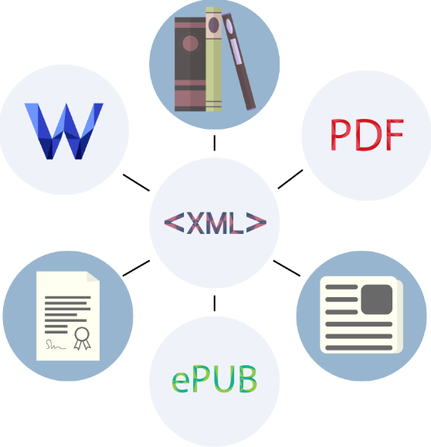

**Table of Contents**

1. Executive Summary 2

2. Introduction 3

3. Single-Source Publishing 4

3.1. Why single-source publishing 4

3.2. What is single-source publishing 5

3.3. The benefits of single-source publishing 7

3.4. How to implement single-source publishing 8

3.5. Tools for single-source publishing 8

3.6. The concerns when shifting to single-source publishing 9

4. Conclusion 11

5. Recommendations 12

6. Bibliography 13

## 1. Executive Summary

Single-source publishing is a content production-and-publishing system that promises authoring once and publishing anywhere. It enables organizations to deliver quality content in a timely manner and at much lower cost compared to the traditional content-management method.

In the traditional content-management system, several versions of the same content are typically created and edited for different publishing media. This causes content redundancy. When any changes to the content are required because of product updates, modifications need to be applied to all versions of the same content. This wastes human energy and money, lengthens the production delivery cycle, and increases the chances of having errors caused by manual formatting.

Single-source publishing divides the content production into two phases: authoring and publishing. For the authoring phase, content is separated into small parts called topics, and only one version is stored for the content no matter what the publishing media are. For the publishing phase, the system uses transformation modules to convert the structured content to the desired formats based on the publishing medium.

Single-source publishing greatly reduces the workload; therefore, it will reduce cost, shorten production cycles, and improve content quality.

To implement single-source publishing, single-source application tools are required. Several popular tools are introduced in this report. The workflow needs to be rearranged to suit the single-source publishing procedure. Also, the writers need to learn how to use single-source publishing tools for content authoring and publishing.

The tradeoff of using single-source publishing is the lack of diversity in output format. "The essence of single-source publishing is the automation of publishing processes. The more you can standardize and simplify your published outputs, the greater will be the benefits of single-source publishing" (Meyer).

Single-source publishing is an effective and efficient content-management method, which is used more and more widely in the content authoring, editing, and publishing process. The main steps for implementing single-source publishing are explained under Recommendations.

## 2. Introduction

Nowadays, many medium formats are required for publishing content such as user manuals, user guidelines, release notes, etc. In the traditional content-processing procedure, the documents for different publishing media usually are processed separately. All of those files need to be modified separately when the product that the documents describe is updated. An organization that keeps one source file for each different publishing medium needs to maintain multiple versions of the same content. This causes much redundant work in authoring, editing, and formating, and at the same time it is not easy for a content management team to track the changes for different versions.

For this reason, an increasing number of professionals have started to work on how to use a single-source publishing method to save time and money. In this method, only one version of content is created and maintained, allowing production of several different media formats from the same original content.

Single-source publishing is a popular strategy for document and content management which can reduce the cost of authoring, editing, and maintaining the technical content in terms of both human energy and money. “It is clearly something we all need to consider as we attempt to offer cost effective, efficient, and highly impactful learning solutions for the organizations and learners we serve" (Moshe).

Single-source publishing eliminates the redundant work, so an organization can publish content in a shorter period of time and at a lower cost. Maintaining only one source for the same content makes content management easier. Auto-formatting the output content delivers better-quality content, because it avoids the errors caused by manual formatting.

To maximize the benefits of single-source publishing, an organization needs to understand that single-source publishing involves not only a change in editing software, but also a new concept of content processing. So both management teams and writers need to learn how to work to adapt to the single-source publishing system.

Several widely used single-source publishing applications are introduced in this report. An organization can select the suitable application based on its own needs and situation.

The tradeoff of single-source publishing is less output format diversity. Since the main idea of single-source publishing is automation, it is very important to standardize and simplify the output format.

## 3. Single-Source Publishing

This section contains the following topics:

* Why single-source publishing
* What is single-source publishing
* The benefits of single-source publishing
* How to implement single-source publishing
* Tools for single-source publishing
* The concerns when shifting to single-source publishing

### 3.1. Why single-source publishing

As technology progresses, a variety of media formats has been emerging. Besides traditional print materials, there are the PDF format used for reading on the computer, the HTML format used as online searchable content, and the Word format that is easy to read and edit. Even for the same online content, different formats need to be considered to deliver the most comfortable readability for readers because of the different screen sizes of a desktop computer, a tablet, or a smart phone.

In a traditional document-management system, the most likely situation is this: there is one source file for each publishing media format. For example, online help is saved as an html file with Dreamweaver, and the source file for a PDF version is saved in an MS word format. There might also be an InDesign version for paper print. All of these files need to be modified separately when the product that the documents describe is updated.

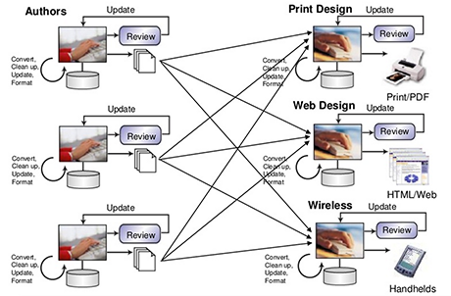

Fig. 1. Traditional content management system (Stagnaro)

Obviously, there is much repetitive work in authoring, editing, and formatting the source content for each media format. Because of the rapid development of technology, most products are updated more and more frequently unless they are no longer used. That leads to the need for frequent changes in the documents that describe the product. Under this circumstance, the editing and formatting for the multiple versions of the same content will be a significant waste of employee time and money.

With globalization becoming increasingly popular, translation is now a huge workload. If multiple versions of the same content need to be translated, the expense is significantly more than that of translating only one version of the same content.

Finally, when all the different formats of the documents are manually processed, not only will the workload will be extremely heavy, but there will be more chances for human error. The quality of the content will be compromised, and the delivery time can't be guaranteed.

Because of the issues mentioned above, it is obviously necessary to introduce a content-publishing system that can minimize workloads, improve publishing quality, deliver content in a timely manner, and reduce overall costs, especially those of human power.

### 3.2. What is single-source publishing

Single-source publishing is a process that organizes technical content in one place and publishes the content into different media or formats from the same original source. Single-source publishing can reduce the human energy and money typically involved in authoring, editing, maintaining, and publishing content. With the rapid development of technology, the product update cycle becomes shorter and shorter; therefore, it is becoming even more important to deliver updated documents in a timely manner, with exceptional quality, and at a reasonable cost.

The single-source publishing system divides the content publishing processes into two phases: the first phase is authoring, and the second phase is publishing.

#### Authoring

First, all the content is organized in only one place without duplicated versions, so that only one content source needs to be modified when the product it describes is updated. Repeated work is avoided, because no duplicated version in any other place needs to be modified. Especially when translation is required due to globalization needs, an organization will greatly reduce translation expenses for duplicated versions of source content.

Second, all content is organized in a structured manner; that is, a big trunk document is divided into many small parts called topics. For each topic, there is a group of data called metadata to describe the features of the topic. This structure makes it possible for the transformation modules to convert the content to the format of the publishing medium.

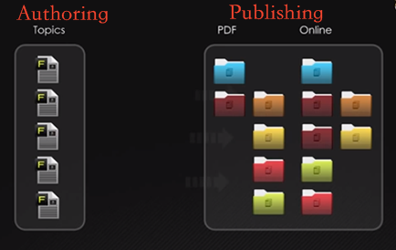

Fig. 2. Single-source publishing system ("An Overview of MadCap Flare")

#### Publishing

Transformation modules are designed to conduct the formatting work automatically. A specific transformation module is designed for each publishing output format, so one can get the desired format for one publishing medium by selecting the right transformation module. Auto-formatting makes the whole publishing process faster, delivers consistent layout of published content, and eliminates the errors caused by manual formatting.

#### XML and single-source publishing

One of the essential features of single-source publishing is that it separates content structure from appearance; this is implemented by using an XML-based documentation system.

An XML file uses tags to define content structure. All content in XML is wrapped in tags. A DTD file defines the tags that are valid to be used in an XML file and contains the rules about how to use the tags. An XSLT file is used to transform XML tags to XHTML tags, so the content of the XML source file can be displayed in a browser. XSLT makes it possible for the same source XML file to be displayed in a different format by adding, removing and changing the content of XML file. An XSL-FO file is also a stylesheet which is used most frequently to transform an XML source file to a PDF document.

### 3.3. The benefits of single-source publishing

Overall, single-source publishing can benefit an organization in the following ways:

#### Reduce the workload tremendously

In a traditional content-management system, usually more than one source exists for the same content due to different publishing media. For all the different versions of the content, authoring, editing, and formatting are likely conducted separately. In a single-source publishing system, however, the workflow is clearly divided into two phases: authoring and publishing. In the authoring phase, the content is organized as structured documents made of many topics. In the publishing phase, transformation modules can convert the content to the desired format.

Obviously maintaining only one version of the same content greatly reduces the workload compared to that involved in maintaining several different versions. The auto-formatting function of the transformation modules in a single-source publishing system completely replaces the manual formatting work in a traditional content-management system.

#### Save human resources and money

Maintaining only one source for each part of the content and auto-formatting reduces workload significantly; therefore, the savings of human resources and money will be considerable.

#### Deliver product in a timely manner

The automation of converting the source content to different desired formats shortens the production time, so that the final published product can be delivered to users much faster than when using a traditional content management system.

#### Eliminate errors caused by manually re-formatting

Because auto-formatting modules replace manual formatting in the single-source publishing system, human errors are avoided.

#### Make content management easier

The content is saved in only one source, so it is easy to keep track of the content when product updates necessitate modification.

#### Increase the efficiency of an organization

When an organization can deliver quality product in a timely manner, it attracts more customers and most likely makes more sales. The reduced publishing costs make the organization financially robust. All of these assets increase the organization's competency in the competitive market.

### 3.4. How to implement single-source publishing

The management team needs to realize that single-source publishing is not "just a change in file format like moving from one office application to another" (Meyer) and that the main goals are "to replace redundant, manual tasks with automated processes wherever possible and to improve the accuracy and consistency of published documents" (Meyer).

Although single-source publishing depends on a software application for implementation, the people who are involved in the process are even more important.

To implement single-source publishing, the work that needs to be done can be divided into the following categories:

**Funding:** Funding is essential. Senior management members need to realize the importance and necessity of single-source publishing, so that they will approve the funding for implementing single-source publishing. The funding should cover the costs of software, of training, and the cost for converting current content to the format required by single-source publishing.

**Content-management team:** The content-management team should understand that single-source publishing involves not only a change of content-authoring tools, but also a totally different manner of working. They need to re-arrange workflow and re-allocate human resources to adapt to the new working process. They also need to consider how to convert legacy content and train writers.

**Content writers:** Content writers need to recognize the advantages of single-source publishing and be willing to learn how to use the single-source publishing tools for authoring, editing, and publishing content. If the project is big enough, they also need to learn how to use version control software to coordinate their work. Usually specific training is required for this.

**Software application:** A single-source publishing application needs to be selected. Software applications play a very important role in single-source publishing systems, because automation is the core concept of the system. The management team needs to consider the practical situation and the different features of software applications to decide which application to use. If necessary, specialist consultants should be invited to help make the decision.

### 3.5. Tools for single-source publishing

Software applications are necessary to implement single-source publishing. The software application consists mainly of two parts: authoring and transformation (formatting), correspondent with the two phases of single-source publishing processes, authoring and publishing.

The authoring part creates the content as structured documents; the transformation part consists of converting modules for different medium formats. All single-source publishing applications have these two basic parts; each application also has its own additional features.

The following are some single-source publishing applications on the market.

**Adobe FrameMaker** is a powerful software application for authoring, enriching, managing, and publishing XML/DITA and unstructured content. Like other software applications from Adobe, it is good-quality software and convenient to use. It supports multiple channels, formats, and screens, and it can be used for both structured content and unstructured content. Its strength is that it can well support rich multimedia such as audio, video, and 3-D.

**MadCap Flare** is an application used to create user guides, online help systems, knowledge bases, eBooks, manuals, etc. It organizes the content into topics and supports topic-based authoring. It can convert existing content from word format to topic-based content, and this is a very useful feature for organizations that plan to use a single-source publishing system and have lots of legacy unstructured content that needs to be converted.

**Author-it** is a Saas- (software as a service) and cloud-based single-source publishing application. It includes a feature-rich editor, component CMS (using MS SQL Server), multi-channel publishing, and translation management. Author-it uses a template that can be modified to control the format of output content. Its output includes PDF, PowerPoint, online SHTML, web CMSs, DITA, and Adobe formats. The Saas and cloud features let users access the application from anywhere a browser and Internet connection is available at a lower upfront cost.

**XMLSpy** is a single-source publishing application. The authoring part lets users author content into an XML file that consists of many small topics. The transformation part has different converting modules that users can select according to their needs. After selecting the desired converting module, users can run the transformation function to get a publishing result with the desired format. All formats are converted automatically without human interference.

### 3.6. The concerns when shifting to single-source publishing

To shift to a single-source publishing system from a traditional content-management system, there are two issues that need to be considered:

#### Convert the legacy documents

Single-source publishing is not only a strategy but also a concept. Its core idea is automation, letting software do the work of formatting content. Because we use software applications to work on formatting, we need to prepare the content differently from the way it is prepared in a traditional content-authoring system.

In a single-source publishing system, the content has to be divided into small sections called topics. For each topic, there is described message or metadata about it. The metadata will be used to transform topics to different desired formats.

Some organizations have legacy source content existing in different formats, most likely in Microsoft Word, and being saved in big chunks, or as unstructured documents. Some single-source publishing applications have modules to help users convert legacy unstructured documents to structured documents in XML format. The content-management team of the organization needs to be concerned with converting legacy documents when they shift to a single-source publishing system from a traditional content-management system.

#### Standardize and simplify output format

In a traditional content-management system, the content is saved and processed separately for different publishing media. These documents usually are manually formatted in a very unique or even creative style. But in a single-source publishing system, the output format should be kept standard and simple, otherwise the complexity of the transformation software will outweigh the convenience of using the single-source publishing application.

In order to maximize the benefits of using single-source publishing, it is necessary to standardize and simplify the output format, and less output diversity is preferred.

## 4. Conclusion

Single-source publishing is an effective and efficient content-management method, which is used more and more widely in the content authoring, editing, maintaining, and publishing process.

When single-source publishing is used in an organization, the documentation can be easily converted into the desired media format according to the users' requirements. This method can deliver the new or updated content with better quality and in a timely manner. At the same time this method saves huge amounts of repeated work compared to what is required when single-source publishing is not used; therefore, it reduces the costs for the organization. All these advantages will increase the competency of the organization.

To use the single-source publishing method, a single-source publishing software application is required. Technical writers need to learn how to use the application to author content. Most importantly the content management team should understand that they need to re-design a new workflow to suit the single-source publishing system.

Several commonly used single-source publishing tools are introduced in this report. Organizations might need to consult with single-source publishing specialists to select the proper tools according to their practical situations.

A single-source publishing system can help to cut project time, increase productivity, reduce localization costs, streamline content delivery, and improve the quality and consistency of publishing content. As a technical writer, both understanding single-source publishing and learning related technology are very important.

## 5. Recommendations

To implement single-source publishing, the content-management team needs to take the following actions:

#### Select tools

There are many applications on the market, and each one has special features in addition to the basic functions of single-sourcing publishing applications. Select the tool that is suitable to the practical situation of your organization. If necessary, consult a single-source publishing specialist for help.

#### Design workflow to adapt to the single-source publishing system

Implementation of single-source publishing involves more than a change of software tools for content production. It is a totally new concept of content management. To maximize the benefits from single-source publishing, the workflow should be different from that suitable for traditional content-management methods. The whole workflow needs to be re-designed, so that the single-source publishing system can really benefit the organization.

#### Educate content writers

Train content writers. It is very important for content writers to learn how to use single-source publishing tools to author content. The single-source publishing system will be successful only if content writers can use the authoring tools properly.

#### Convert existing documents

If the organization has existing documents in an unstructured format, these documents must be converted to structured documents in XML format. Some single-source publishing applications come with modules that can convert legacy content to the format that can be used in the new system. Management teams should consider this factor when selecting single-source publishing tools.

## 6. Bibliography

“An Overview of MadCap Flare." Madcapsoftware. MadCap Software. January 16, 2014 <http://www.madcapsoftware.com/products/flare/>

Bodnik, Susan. "XML Basics for Technical Writers." Online-learning. January 16, 2014 <http://online-learning.com/blog/xml-basics-for-technical-writers-2/>

Meyer, Peter. "Single source publishing FAQ." Elkera. 11 July 2008. Elkera. 25 Dec. 2013 <http://www.elkera.com.au/cms/articles/technical_papers/single_source_publishing_faq/>.

Mosher, Bob. "Has Single-Source Publishing FINAL Com of Age." Performancesupport. February 13, 2009. January 8, 2014 <http://performancesupport.blogspot.ca/2009/02/has-single-source-publishing-finally.html>.

Rouse, Margaret. "Definition Single sourcing." Techtarget. September 2005. 25 Dec. 2013 <http://searchsoa.techtarget.com/definition/single-sourcing>.

"Single source publishing." Wikipedia. 25 Dec, 2013 <http://en.wikipedia.org/wiki/Single_source_publishing>.

Stagnaro, Mike. "Single source publishing: utilizing XML and DITA." Slidshare. May 20, 2013. January16, 2014 <http://www.slideshare.net/stc-pmc/single-source-publishingxmldita>

Weber, Kai. "Second day of sessions at TCUK 13." Kai's Tech Writing Blog. September 26, 2013. January 8, 2014. <http://kaiweber.wordpress.com/category/single-sourcing/>.